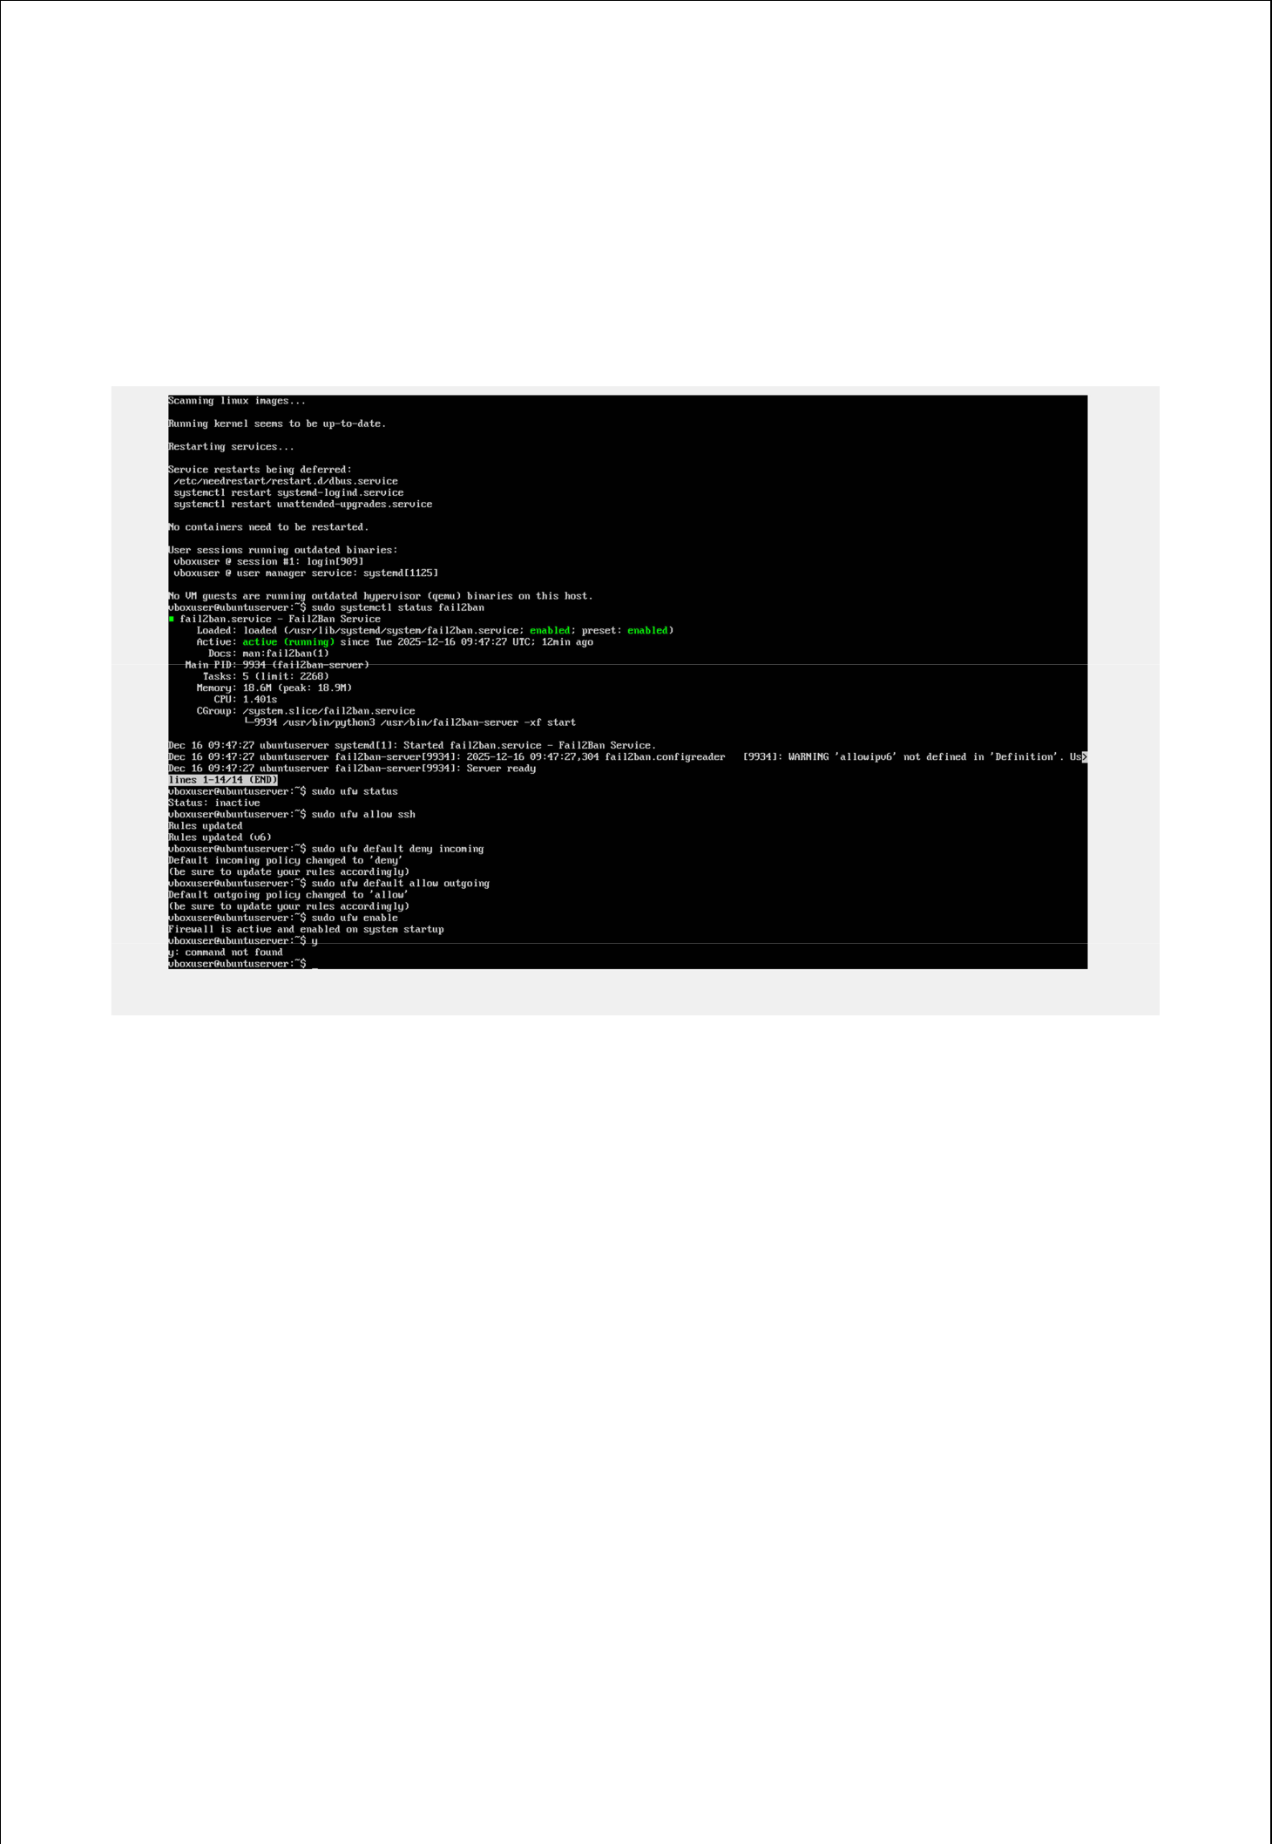
Week 6

Monitoring and Automation:

Installation of firewall:
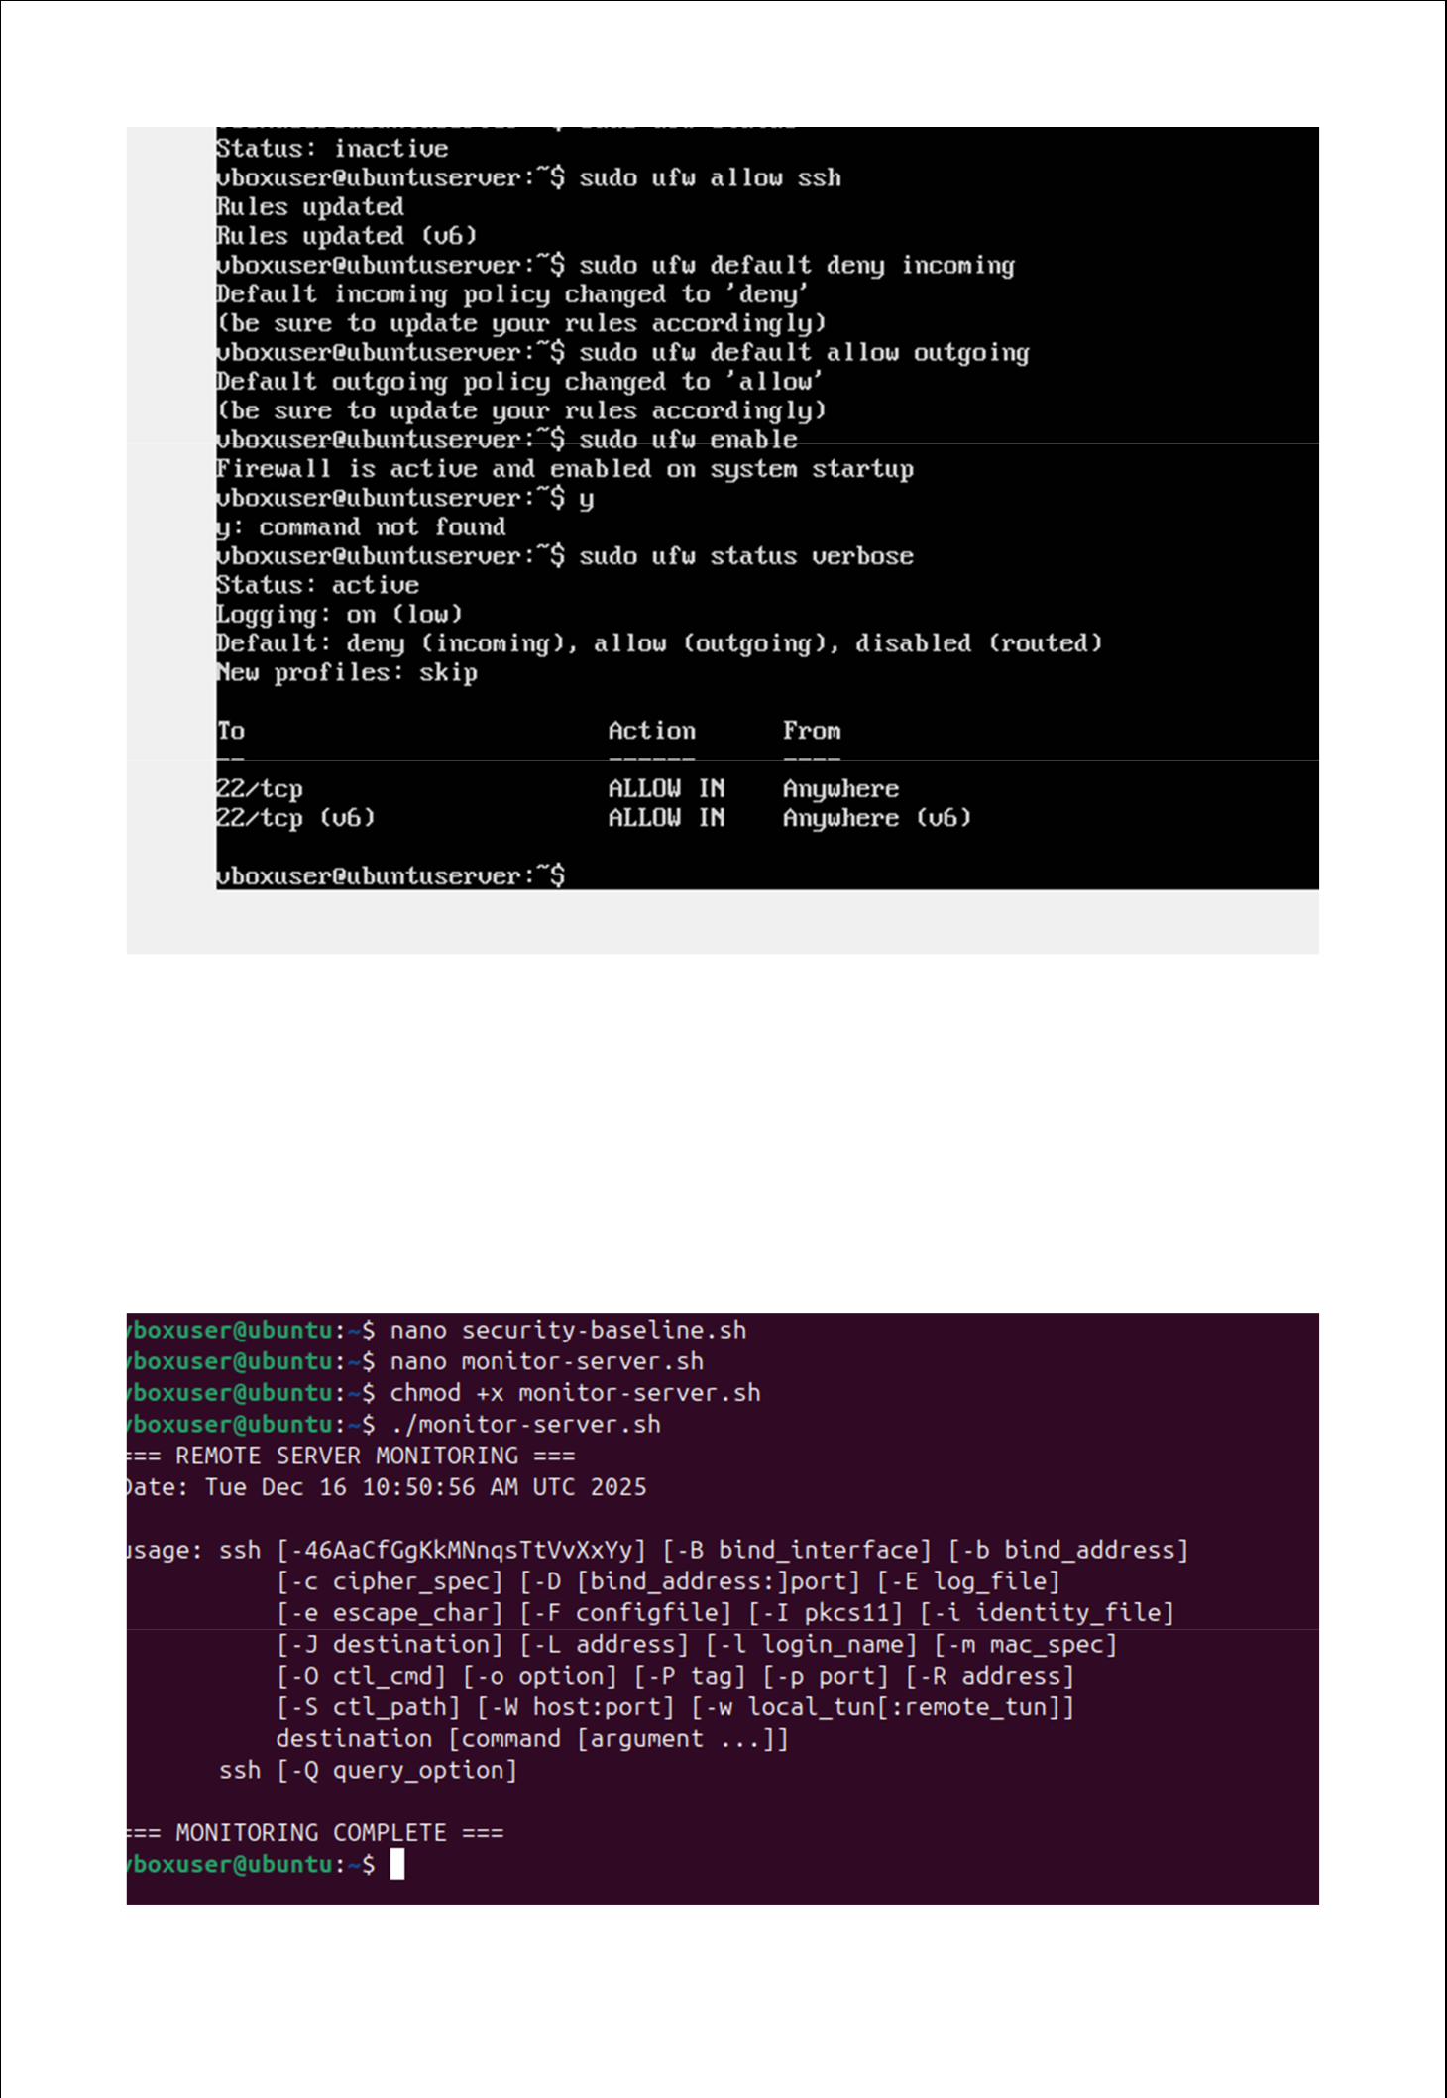

Remote Monitoring Script on workstation:

I have created monitoring script on workstation to collect server metrics via SSH.
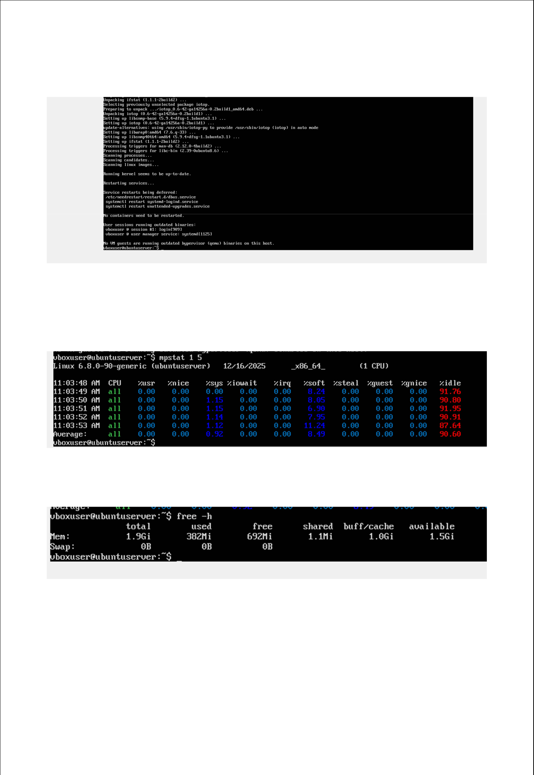

Installation:

Monitoring Strategy:

CPU, memory, disc, and uptime were among the performance metrics that were tracked.
